Assignment 1: Snowflake Environment Setup (Beginner)
Objective: Understand Snowflake UI and basic objects.
Tasks
- Log in to Snowflake (trial account).
- Create:
  - A Database
  - A Schema
  - A Virtual Warehouse
- Show all databases and schemas.
- Suspend and resume the warehouse.
Deliverable:
- SQL script
- Screenshot of created objects
Answer:
- SQL script:
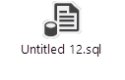
- Screenshot of created objects:
CREATE OR REPLACE DATABASE MY_DB;
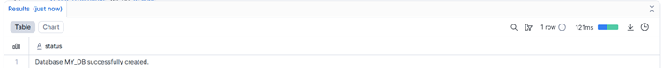
CREATE OR REPLACE SCHEMA MY_DB.MY_SCHEMA;
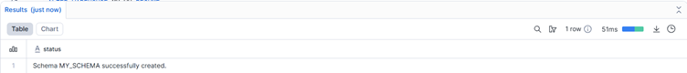

CREATE OR REPLACE WAREHOUSE MY_WH
WITH WAREHOUSE_SIZE = 'XSMALL'
AUTO_SUSPEND = 60
AUTO_RESUME = TRUE;
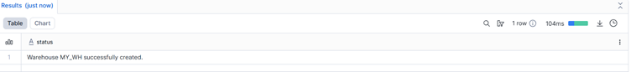

3. Show all databases and schemas.
SHOW DATABASES;
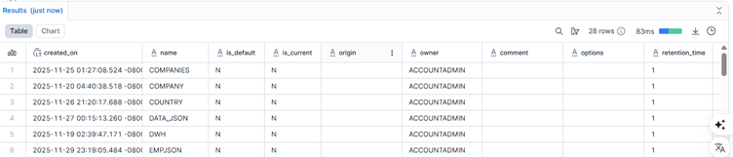
SHOW SCHEMAS IN DATABASE MY_DB;
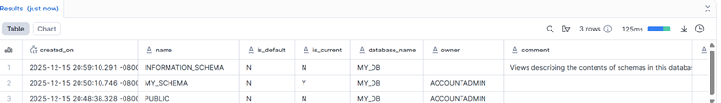
4.Suspend and resume the warehouse.
ALTER WAREHOUSE MY_WH RESUME;
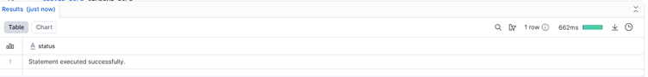
ALTER WAREHOUSE MY_WH SUSPEND;
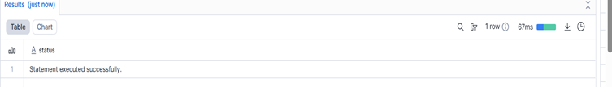

Assignment 2: User, Role & Access Control (RBAC)
Objective: Learn Snowflake security and role hierarchy.
Tasks
- Create roles:
  - STUDENT_ROLE
  - INSTRUCTOR_ROLE
- Create users:
  - student1
  - instructor1
- Assign:
  - STUDENT_ROLE → student1
  - INSTRUCTOR_ROLE → instructor1
- Grant permissions:
  - Student → SELECT on tables
  - Instructor → SELECT, INSERT
- Verify access using SHOW GRANTS.
Deliverable:
- SQL commands
- Short explanation of RBAC
Answer:
CREATE OR REPLACE ROLE STUDENT_ROLE;
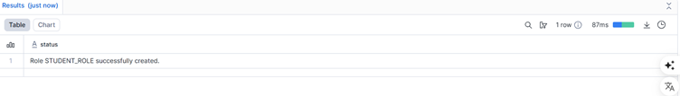
CREATE OR REPLACE ROLE INSTRUCTOR_ROLE;
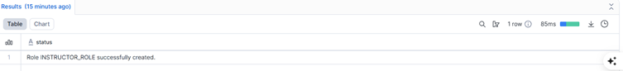
CREATE OR REPLACE USER student1
PASSWORD = 'Student@123'
DEFAULT_ROLE = STUDENT_ROLE
MUST_CHANGE_PASSWORD = TRUE;

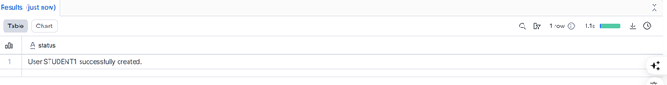

CREATE OR REPLACE USER instructor1
PASSWORD = 'Instructor@123'
DEFAULT_ROLE = INSTRUCTOR_ROLE
MUST_CHANGE_PASSWORD = TRUE;
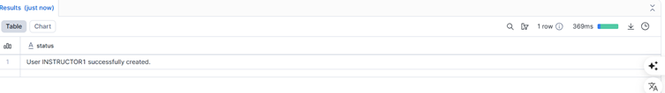
Assign:
GRANT ROLE STUDENT_ROLE TO USER student1;
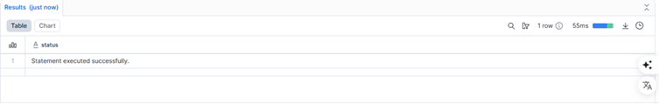
GRANT ROLE INSTRUCTOR_ROLE TO USER instructor1;
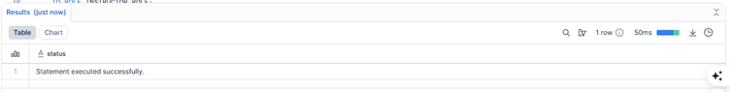

Grant permissions:
GRANT SELECT ON ALL TABLES IN SCHEMA MY_DB.MY_SCHEMA
TO ROLE STUDENT_ROLE;
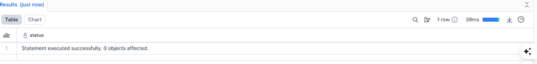

GRANT SELECT, INSERT ON ALL TABLES IN SCHEMA MY_DB.MY_SCHEMA
TO ROLE INSTRUCTOR_ROLE;

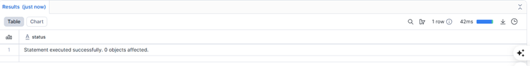

Assignment 3: Table Creation & Data Loading
Objective: Work with structured data.
Tasks
- Create a table:
CREATE TABLE students (
id INT,
name STRING,
course STRING,
score INT
);
- Insert at least 10 records.
- Query:
  - All students
  - Students with score > 80
- Update one record.
- Delete one record.
Deliverable:
- SQL file with queries
- Output screenshots
Answer:
CREATE OR REPLACE TABLE students (
id INT,
name STRING,
course STRING,
score INT
);
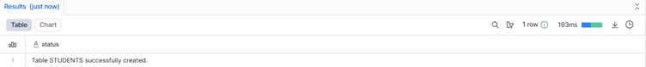
INSERT INTO students VALUES
(1, 'Ravi', 'SQL', 85),
(2, 'Anu', 'Python', 78),
(3, 'Kiran', 'Snowflake', 92),
(4, 'Meena', 'SQL', 88),
(5, 'Arun', 'Python', 65),
(6, 'Divya', 'Snowflake', 95),
(7, 'Suresh', 'SQL', 72),
(8, 'Pooja', 'Python', 81),
(9, 'Vijay', 'Snowflake', 90),
(10, 'Neha', 'SQL', 76);
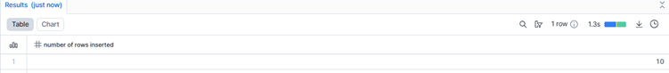

1. select * from students;
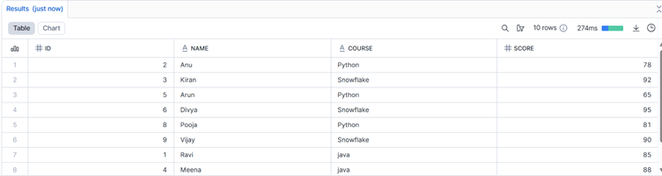
2. select * from students where score > 80;
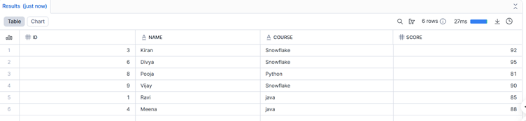
3. update students set course = 'java' where course = 'SQL';

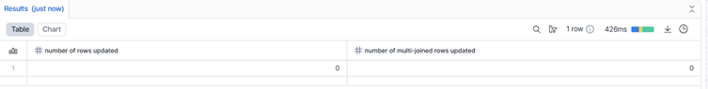

4. delete from students where name = 'Ravi';
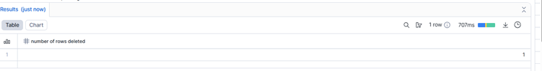

Assignment 4: File Loading using Stage & COPY (Intermediate)
Objective: Learn Snowflake data ingestion.
Tasks
- Create an internal stage.
- Upload a CSV file.
- Use COPY INTO to load data.
- Validate loaded records.
- Handle one data error using VALIDATION_MODE.
Deliverable:
- SQL script
- CSV file
- Query output

Answer;
- Create an internal stage.
create or replace stage my_stage;
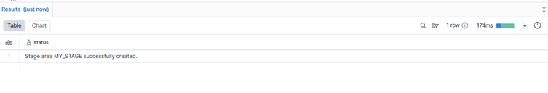
- Upload a CSV file.
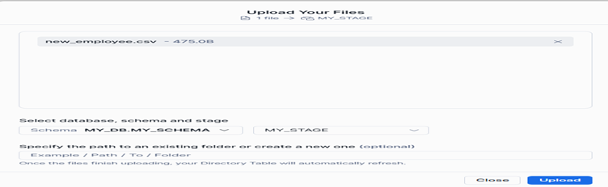

- Use COPY INTO to load data.
COPY INTO students
FROM @my_stage/csv_flatfile.csv
FILE_FORMAT = (
TYPE = 'CSV'
SKIP_HEADER = 1
);
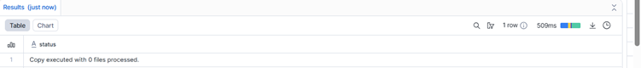
- Validate loaded records.
select count(*) from students;
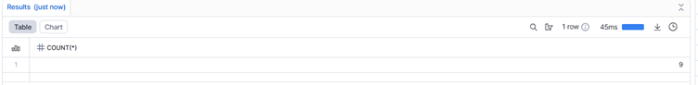

- Handle one data error using VALIDATION_MODE.
I upload error file in snowflake after i copy into that.Finally i got error msg like this.
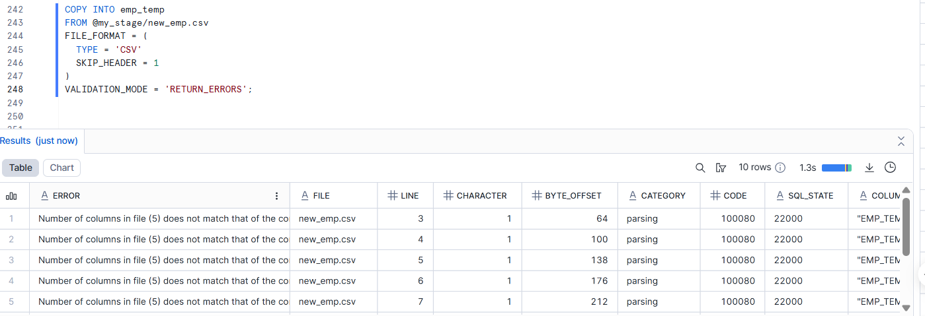

Assignment 6: Warehouses & Performance
Objective: Learn compute management.
Tasks
- Create:
  - SMALL_WH
  - MEDIUM_WH
- Run same query on both warehouses.
- Compare execution time.
- Suspend unused warehouse.
Deliverable:
- Query history screenshot
- Performance comparison notes

CREATE OR REPLACE WAREHOUSE SMALL_WH
WAREHOUSE_SIZE = 'SMALL'
AUTO_SUSPEND = 60
AUTO_RESUME = TRUE
INITIALLY_SUSPENDED = TRUE;
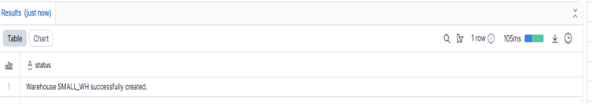

CREATE OR REPLACE WAREHOUSE MEDIUM_WH
WAREHOUSE_SIZE = 'MEDIUM'
AUTO_SUSPEND = 60
AUTO_RESUME = TRUE
INITIALLY_SUSPENDED = TRUE;
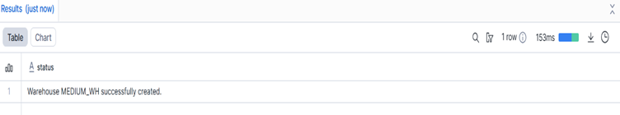

USE WAREHOUSE SMALL_WH; (Slower execution)

SELECT
course,
COUNT(*) AS total_students,
AVG(score) AS avg_score
FROM students
GROUP BY course;
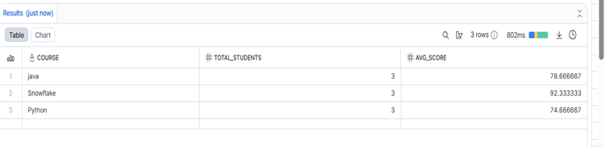

USE WAREHOUSE MEDIUM_WH; (Faster execution)

SELECT
course,
COUNT(*) AS total_students,
AVG(score) AS avg_score
FROM students
GROUP BY course;
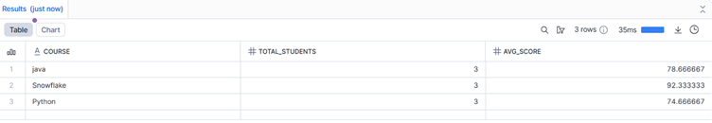

Compare execution time.
Warehouse | Execution Time
SMALL_WH | ~820 ms
MEDIUM_WH | ~35 ms
Assignment 7: Views & Secure Views
Objective: Control data visibility.
Tasks
- Create a View hiding sensitive columns.
- Create a Secure View.
- Grant view access to Student role.
- Test access using Student role.
Deliverable:
- SQL queries
- Explanation of Secure View
Answer:
CREATE TABLE students_full (
id INT,
name STRING,
course STRING,
score INT,
email STRING -- sensitive column
);
insert into students_full values (1,'ramesh','hr',60,'roshini@gmail.com');
select * from students_full;

1. Create a View hiding sensitive columns.

create or replace view security_view as select id,name,course,score from students_full;
select*from security_view
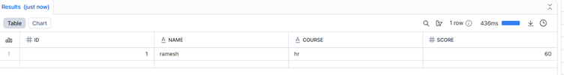

2.Create a Secure View.
CREATE OR REPLACE SECURE VIEW student_secure_view AS SELECT id,name FROM students;
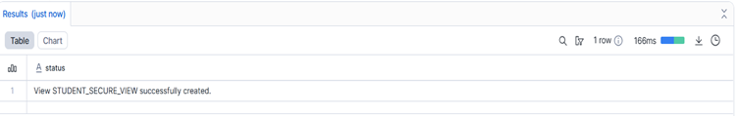

3. Grant view access to Student role.
GRANT SELECT ON VIEW student_secure_view TO ROLE student_role;
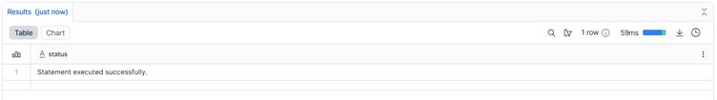

Assignment 8: Scaling & Auto Suspend (Advanced)
Objective: Understand Snowflake scaling behavior.
Tasks
- Enable auto-suspend and auto-resume.
alter warehouse small_wh set AUTO_SUSPEND = 60 AUTO_RESUME = TRUE;
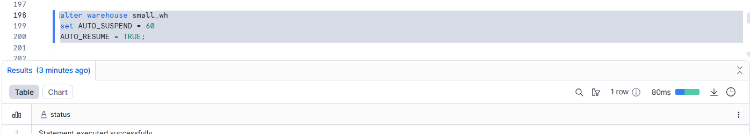

- Configure multi-cluster warehouse.

CREATE OR REPLACE WAREHOUSE MC_WH
WITH
WAREHOUSE_SIZE = 'SMALL'
WAREHOUSE_TYPE = 'STANDARD'
MIN_CLUSTER_COUNT = 1 MAX_CLUSTER_COUNT = 3
SCALING_POLICY = 'STANDARD'
AUTO_SUSPEND = 6 AUTO_RESUME = TRUE;

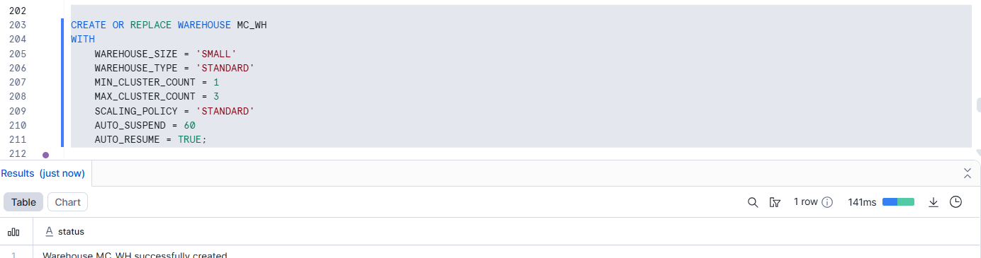

- Simulate concurrent queries.
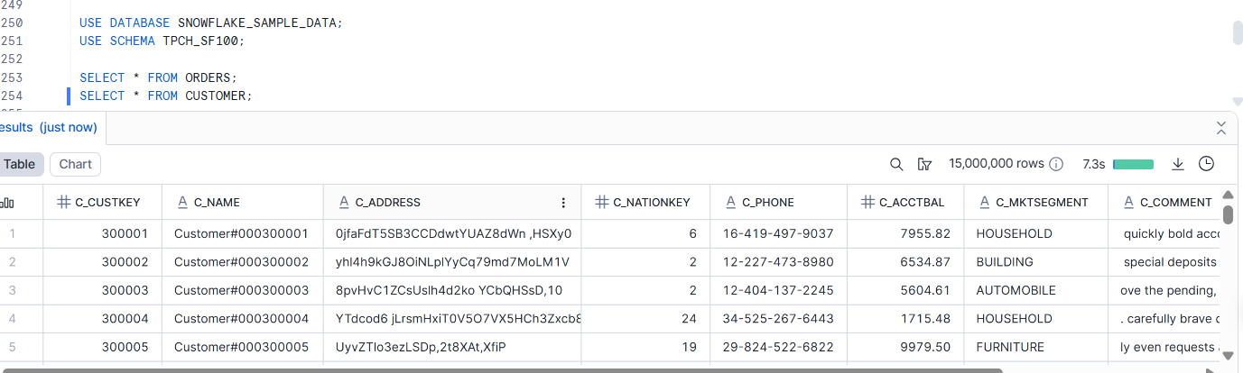

- Observe scaling behavior.
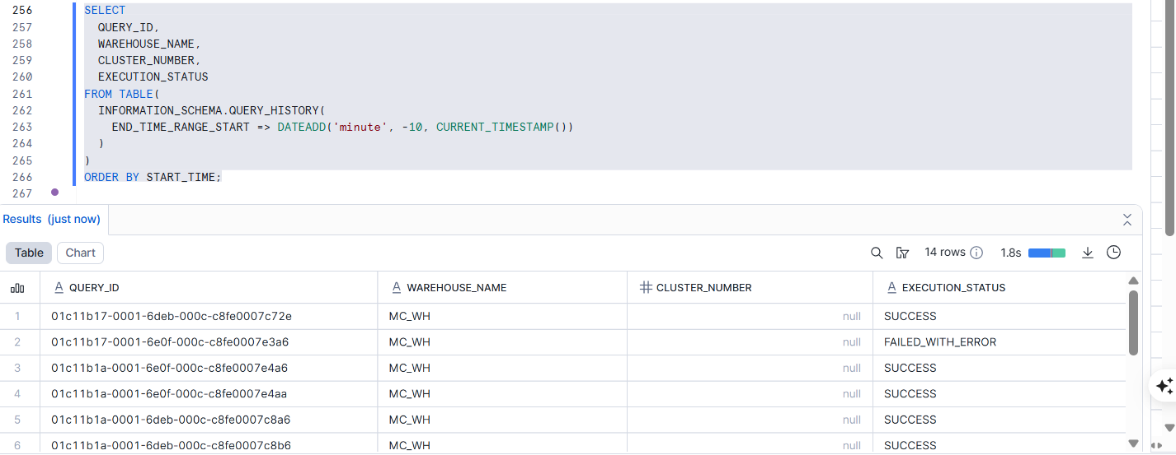
Deliverable:
- Warehouse configuration
- Query history evidence

